**Error Detection**

EDC= Error Detection and Correction bits (redundancy)

D = Data protected by error checking, may include header fields

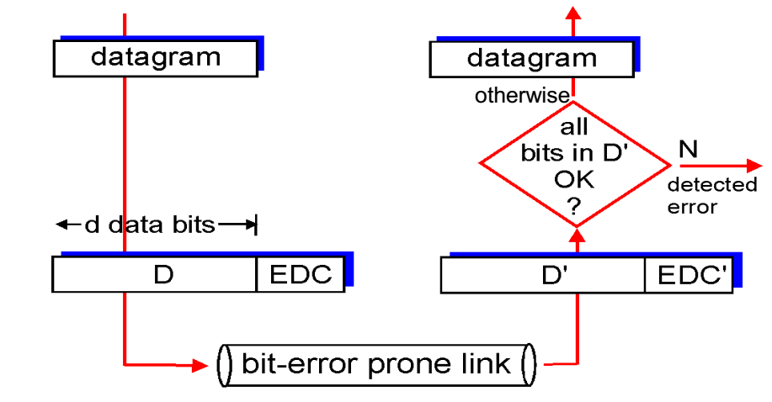

**Parity checking 奇偶校验**

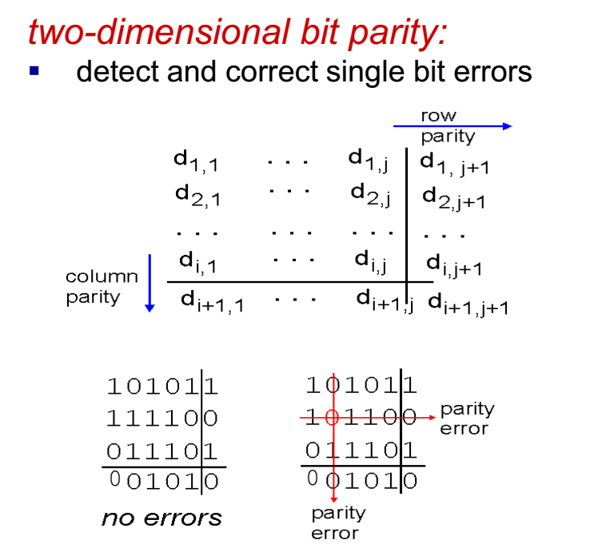

**Internet checksum**

goal: detect “errors” (e.g., flipped bits) in transmitted packet

(note: used at transport layer only)

**循环冗余检测 Cyclic redundancy check**

more powerful error-detection coding

view data bits, D, as a binary number

choose r+1 bit pattern (generator), G

goal: choose r CRC bits, R, such that

<D,R> exactly divisible by G (modulo 2)

receiver knows G, divides <D,R> by G. If non-zero remainder: error detected!

can detect all burst errors less than r+1 bits

